Uploading listing pages on Unily

Pulmonary Policies & Procedures – TJUH, JHN, JMH & Moss-Magee – City Center
|
Template – Pulmonary Policies & Procedures (1)
|
Click on the Ellipses
|
Do something else
|
Copy and paste in the same section selecting Pulmonary Policies & Procedures – TJUH, JHN, JMH & Moss-Magee – City Center
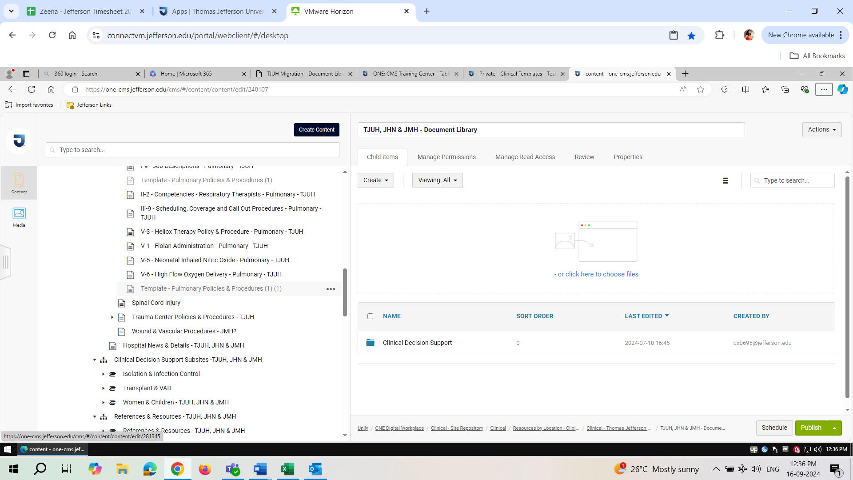

Click on the copy-pasted template
Add the title from TJUH Migration – Document Libraries

