W
WELCOME

THANK YOU VERY MUCH FOR REGISTERING MY UPCOMING WEBINAR ON SSB INTERVIEW.

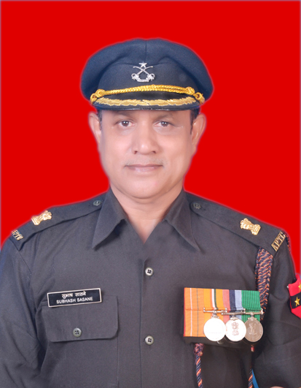
MAJOR SUBHASH SASNE (RETD)
MULTIPLE WORLD RECORD HOLDER

-----------------------------------------------------------------------“JUST DO HARD WORK, THE SKY IS THE LIMIT”
-----------------------------------------------------------------------

INTRODUCTION

I AM MAJOR SUBHASH SASNE, (RETD) AN APTC OFFICER AND A MULTIPLE WORLD RECORD HOLDER. I SERVED MORE THAN 22 YEARS IN THE ARMY PHYSICAL TRAINING CORPS AND INSPIRED THOUSANDS OF SOLDIERS AND YOUTHS.

FOR THE LAST TEN YEARS, I HAVE BEEN SHARING MY STORIES AND JOURNEY TO INSPIRE STUDENTS, THE GENERAL PUBLIC, EX-SERVICEMEN AND THEIR DEPENDENTS TO GROW CONFIDENTLY.

I AM SURE, YOU WILL DEVELOP MANY OFFICER-LIKE QUALITIES WITH THE SSB INTERVIEW BASIC COURSE. NO DOUBT, IT WILL DEFINITELY HELP YOU TO IMPROVE SELF-CONFIDENCE, COURAGE, ORGANISING ABILITIES, DETERMINATION, PHYSICAL AND MENTAL STAMINA, ETC.

THE SSB INTERVIEW IS CONDUCTED IN TWO PHASES

PHASE - I IT IS SCREENING TEST
PHASE - II REMAINING TESTS AT THE SSB

IMPORTANT POINT:
IF YOU RECOMMEND IN PHASE I, YOU ARE RETAINED IN THE SSB FOR THE NEXT FOUR DAYS TO ATTEND REST OF THE TESTS. THE TESTS IN SCREENING ARE DESGINED TO IDENTIFY INDIVIDUALS WHO POSSESS THE POTENTIALTO MOVE FORWARD TO THE LATER STAGES OF TESTING. THEREFORE FIRST DAY IS VERY VERY IMPORTANT IN THE SSB.

SSB 5 DAYS PROCEDURE

DAY ONE - SCREENING TEST

- OIR I - VERBAL TEST - A BOOKLET IS GIVEN TO ALL THE CANDIDATES WITH 50 TO 60 QUESTIONS AND THE TIME IS ALLOWED 25 TO 50 MINUTES TO COMPLETE THE TEST.

EXAMPLES - FIND HIDDEN LETTER/ FIGURE

- A II) C III) B IV) …..?

ANS: …………

- OIR II - NON-VERBAL- A BOOKLET IS GIVEN TO ALL THE CANDIDATES WITH 50 TO 60 QUESTIONS AND THE TIME IS ALLOWED 25 TO 50 MINUTES TO COMPLETE THE TEST.

EXAMPLES - COMPLETION OF SERIES

- DRILL…… SALUTE……… UNIFORM……..?

FLOWER BUS BOOT COACH

ANS:…………

- PPDT: HAZY PICTURE IS SHOWN FOR 30 SECONDS AND 4 MINUTES FOR WRITING A STORY AND LATER NARRATING THE STORY IN FRONT OF THE GROUP.

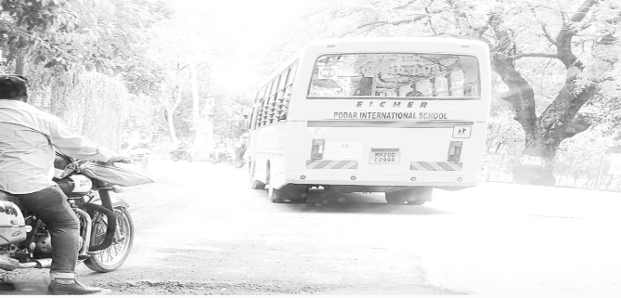

SCREENING RESULTS: IN OR OUT
DAY TWO - PSYCHOLOGY

- THEMATIC APPRECIATION TEST-STORIES ON 12 PICTURES

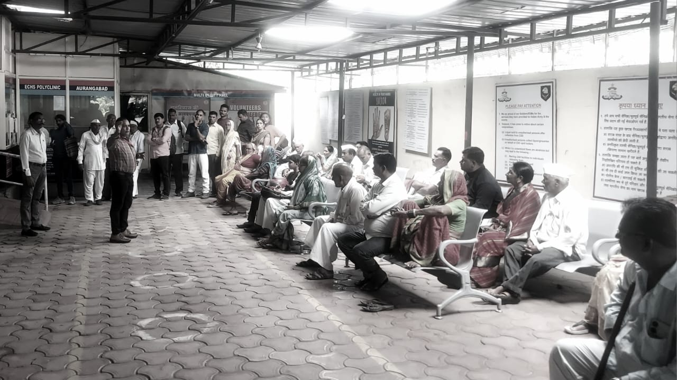

- WORD ASSOCIATION TEST - 60 SENTENCES ON 60 WORDS

EXAMPLE: IDEA, BEAUTIFUL, TEACHER

- SITUATION REACTION TEST - THE CANDIDATE HAS TO REACT ON 60 DIFFERENT SITUATIONS.

- SELF-DESCRIPTION TEST - OPINIONS OF TEACHERS, PARENTS, FRIENDS AND SELF OPINION AND GOAL.

DAY THREE - GTO’S TEST

THE GTO IS A SERIES OF OUTDOOR TASKS IN THE SSB INTERVIEW. IT IS CONDUCTED TO KNOW A CANDIDATES QUALITIES IN A GROUP AND HOW THEY GET INVOLVED WITH EACH OTHER. THERE ARE NINE TESTS FROM THE GROUP DISCUSSION AND THE INDIVIDUAL OBSTACLE TO THE FINAL GROUP TASK IN THE GTO TEST.

INDIVIDUAL OBSTACLE COURSE

THE FOLLOWING 10 OBSTACLES ARE HELD AT THE SSB

- RAMP AND JUMP SNAKE RACE
- DOUBLE BARREL SPIDER WEB
- HIGH WALL DOUBBLE DITCH
- BURMA BRIDGE TARZON SWING
- TIGER LEAP COMMANDO WALK

DAY FOUR - INTERVIEW

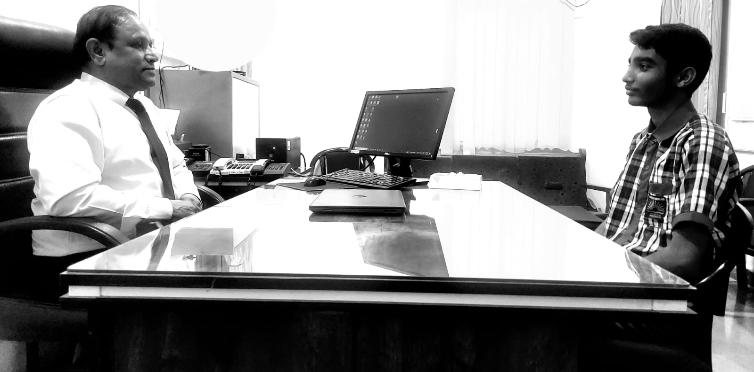

THE INTERVIEW SESSION IS CONDUCTED FOR 45 TO 75 MINUTES TO CHECK ABOUT YOUR FAMILY BACKGROUND, EDUCATION, FRIEND CIRCLE AND GENERAL KNOWLEDGE AND YOUR OVERALL PERSONALITY. APPROXIMATELY 50 TO 60 QUESTIONS ARE FRAMED DURING THE INTERVIEW. THE INTERVIEWING OFFICER PREPARES MANY QUESTIONS BASED ON YOUR PIQ FORM. THE RAPID-FIRE 7 TO 8 QUESTIONS ARE ALSO ASKED TO CHECK YOUR POWER OF EXPRESSION QUALITIES.

DAY FIVE - CONFERENCE
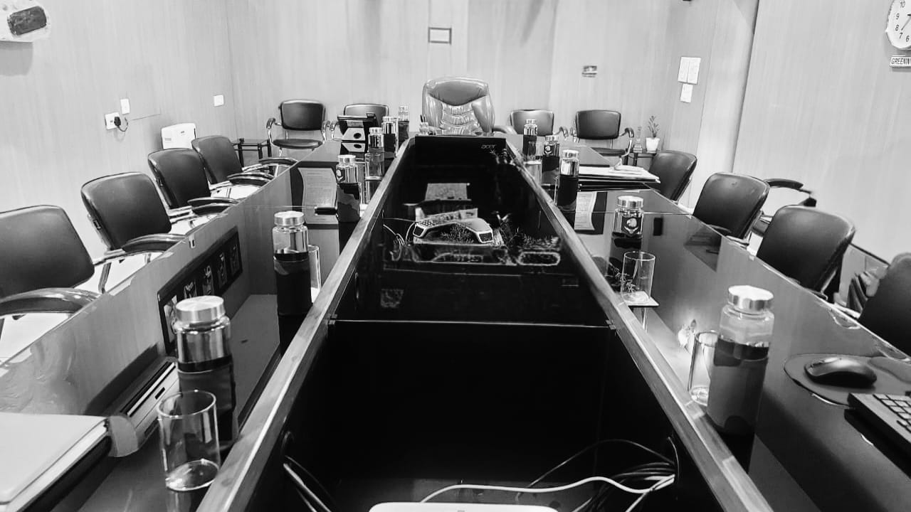
CONFERENCE IS THE LAST DAY OF SSB
- RESULTS
- DISPOSAL OF THE CANDIDATES
--------------------------------------------------------------------------------------------
***** IN ADDITION TO FIVE DAYS PROCESS, WE WILL BE FOCUSING IN THE WEBINAR ON THE ADDITIONAL INFORMATION i.e. SSB CENTRES, COMMANDS, HEADQUARTERS AND THE 15 - OFFICER LIKE QUALITIES ETC.

PLEASE VIEW THE FOLLOWING
INSTAGRAM: majorsubhash YOUTUBE: major subhash sasne
JOIN WHATSAPP GROUP MY AUTOBIOGRAPHY
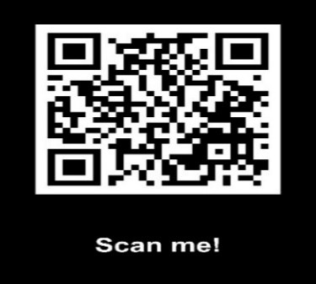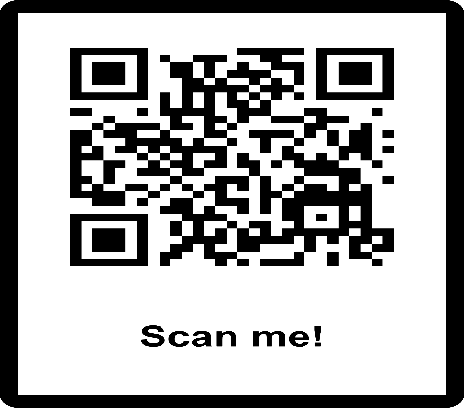

-------------------THANK YOU-------------------
GOOD LUCK FOR YOUR SSB ATTEMPT

