Smart Social Media Manager Toolbox
Congratulations on taking the first step towards revolutionizing your social media marketing strategy! At Growth Empirez, we are thrilled to be part of your journey to online success. This downloadable toolbox is your ultimate companion, expertly curated to equip you with the essential resources and insights needed to elevate your online presence and drive meaningful results.
Inside this toolbox, you'll discover a treasure trove of invaluable resources designed to optimize every aspect of your social media marketing journey. From prospecting and sales techniques to client onboarding strategies, content creation guidelines, and advanced reporting methods, we've covered it all to ensure you have everything you need to succeed.
Each section has been meticulously crafted, drawing upon years of experience and proven best practices. Whether you're a seasoned professional looking to refine your approach or a newcomer eager to learn the ropes, this toolbox caters to all skill levels and ambitions.
We understand the passion and dedication it takes to grow your brand. That's why Growth Empirez is committed to providing you with tools that not only meet your needs but exceed your expectations. Our mission is to empower you, inspire you, and watch you soar to new heights.
Before diving in, please note that this toolbox is intended for individual use only. Redistribution or sharing of its contents, whether for personal or commercial purposes, is strictly prohibited.
So, what are you waiting for? Let’s embark on this transformative journey together, with Growth Empirez by your side every step of the way!

Prospecting and Sales
At Growth Empirez, we understand the excitement and dedication it takes to grow your business. Here, you'll discover powerful strategies and techniques for finding and attracting potential clients to your social media marketing services. From identifying target demographics to utilizing advanced search tools and prospecting methods, this section equips you with the knowledge and tools necessary to expand your client base effectively.

Dive into a wealth of insights designed to help you initiate meaningful conversations, pitch your services with confidence, and ultimately convert prospects into satisfied clients. Each strategy has been meticulously crafted, drawing upon years of experience and proven best practices.

Whether you're a seasoned professional looking to refine your approach or a newcomer eager to learn the ropes, Growth Empirez is here to support you every step of the way. Let’s turn your passion into a thriving reality!

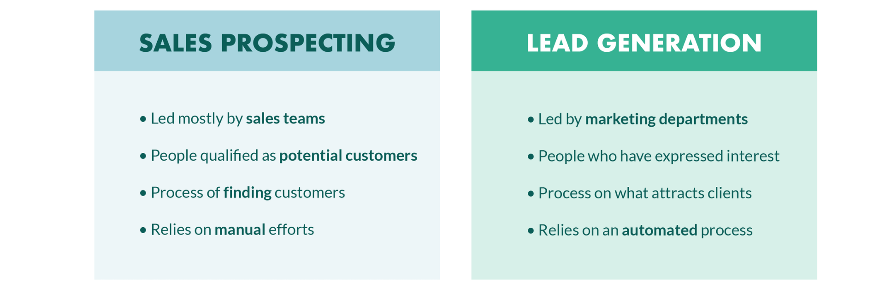
- Lead tracker : | Click Here
- Pre-designed email templates for outreach : | Click Here
- Proposal template : | Click Here
- Sales funnel template : | Click Here
- Portfolio template : | Click Here
- Services and pricing : | Click Here

Client Onboarding
Smooth and successful client onboarding is crucial for establishing strong and lasting relationships. At Growth Empirez, we believe that a great start sets the tone for everything that follows. In this section, you'll find comprehensive guidance on how to effectively onboard new clients into your social media marketing services. From setting clear expectations and goals to creating detailed onboarding processes and communication plans, this section ensures that you start off on the right foot with your clients.
Our expert insights will help you build trust, establish rapport, and lay the foundation for long-term partnerships. With Growth Empirez by your side, you'll be equipped to create a seamless and professional onboarding experience that turns new clients into loyal advocates. Let's embark on this journey together, ensuring every client relationship begins with a strong and positive connection.
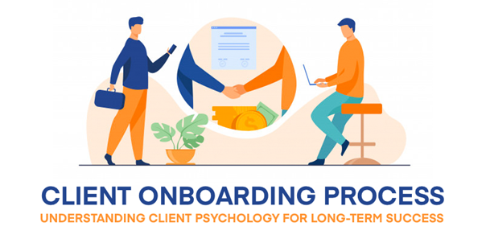

- Discovery call checklist : | Click Here
- Client onboarding questions : | Click Here
- Client welcome email : | Click Here
- Checklist to onboard a client : | Click Here
- Contract resources : | Click Here
- Invoice template : | Click Here

Content Strategy
Crafting compelling and engaging content is at the heart of any successful social media marketing campaign. At Growth Empirez, we understand the power of impactful content. This section provides you with the essential tools and strategies needed to develop a robust content strategy that resonates with your target audience.
Dive into techniques for content ideation, creation, curation, and distribution across various social media platforms. Learn to understand your audience's preferences and optimize your content for maximum reach and engagement. With our expert guidance, you'll be empowered to create content that not only captures attention but also drives real results.
At Growth Empirez, we’re committed to helping you bring your creative vision to life and achieve your marketing goals. Let’s create something extraordinary together!
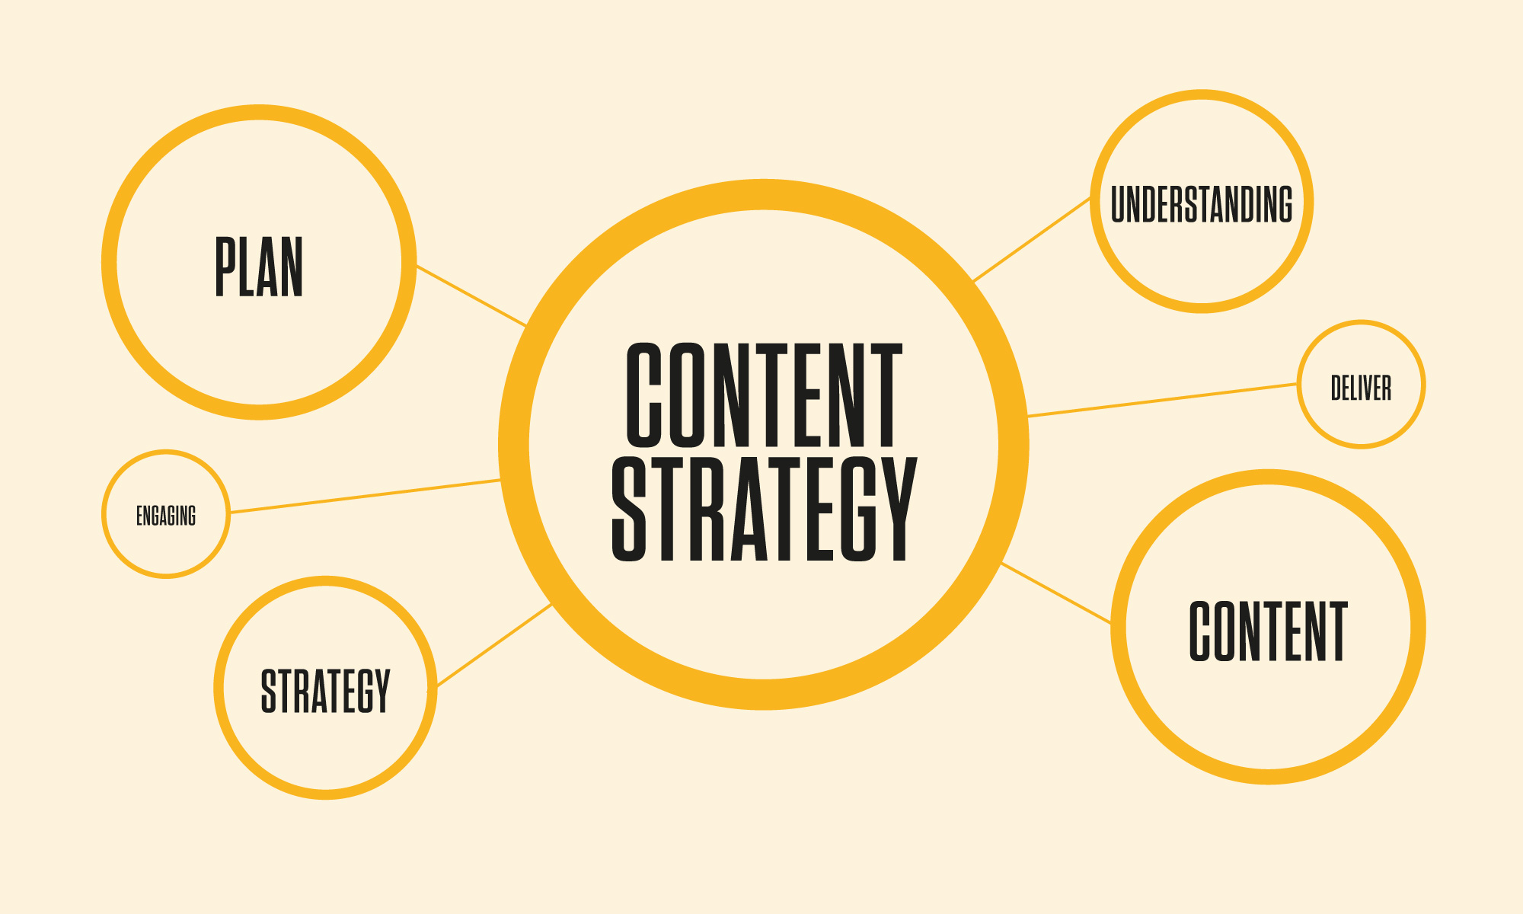
- Buyer persona template : | Click Here
- Competitor analysis template : | Click Here
- Content calendar template : | Click Here
- Engagement tracker : | Click Here
- Instagram audit/optimisation sheet : | Click Here
Reporting
Measuring and analyzing the performance of your social media marketing efforts is key to refining your strategies and maximizing your impact. At Growth Empirez, we know that data-driven decisions lead to success. In this section, you'll learn how to effectively track and analyze key performance indicators (KPIs) to gauge the success of your campaigns.

Discover how to use analytics tools to generate insightful reports and derive actionable insights. Whether it's measuring engagement metrics, conversion rates, or ROI, this section equips you with the knowledge and resources to demonstrate the value of your services to clients and stakeholders.

With Growth Empirez, you'll have the expertise to showcase your achievements and continuously improve your strategies. Let's harness the power of analytics to drive your success and make every campaign count!


- Social media report and analysis : | Click Here
- Email template to ask for testimonials - | Click Here


Bonus Content
- Converting content vault :  (can be used for yourself + for your clients) | Click Here

Copyright Notice
All materials, content, and resources included in this Social Media Marketing Toolbox, including but not limited to courses, toolkits, templates, and bonus content, are protected by copyright law. These resources are intended for individual use only and may not be distributed, reproduced, or shared in any form, whether electronically or otherwise, without explicit permission from Growth Empirez. Unauthorized distribution or sharing of these materials, whether for commercial or non-commercial purposes, is strictly prohibited and may result in legal action. Thank you for respecting the intellectual property rights of Growth Empirez. Your support is invaluable.

