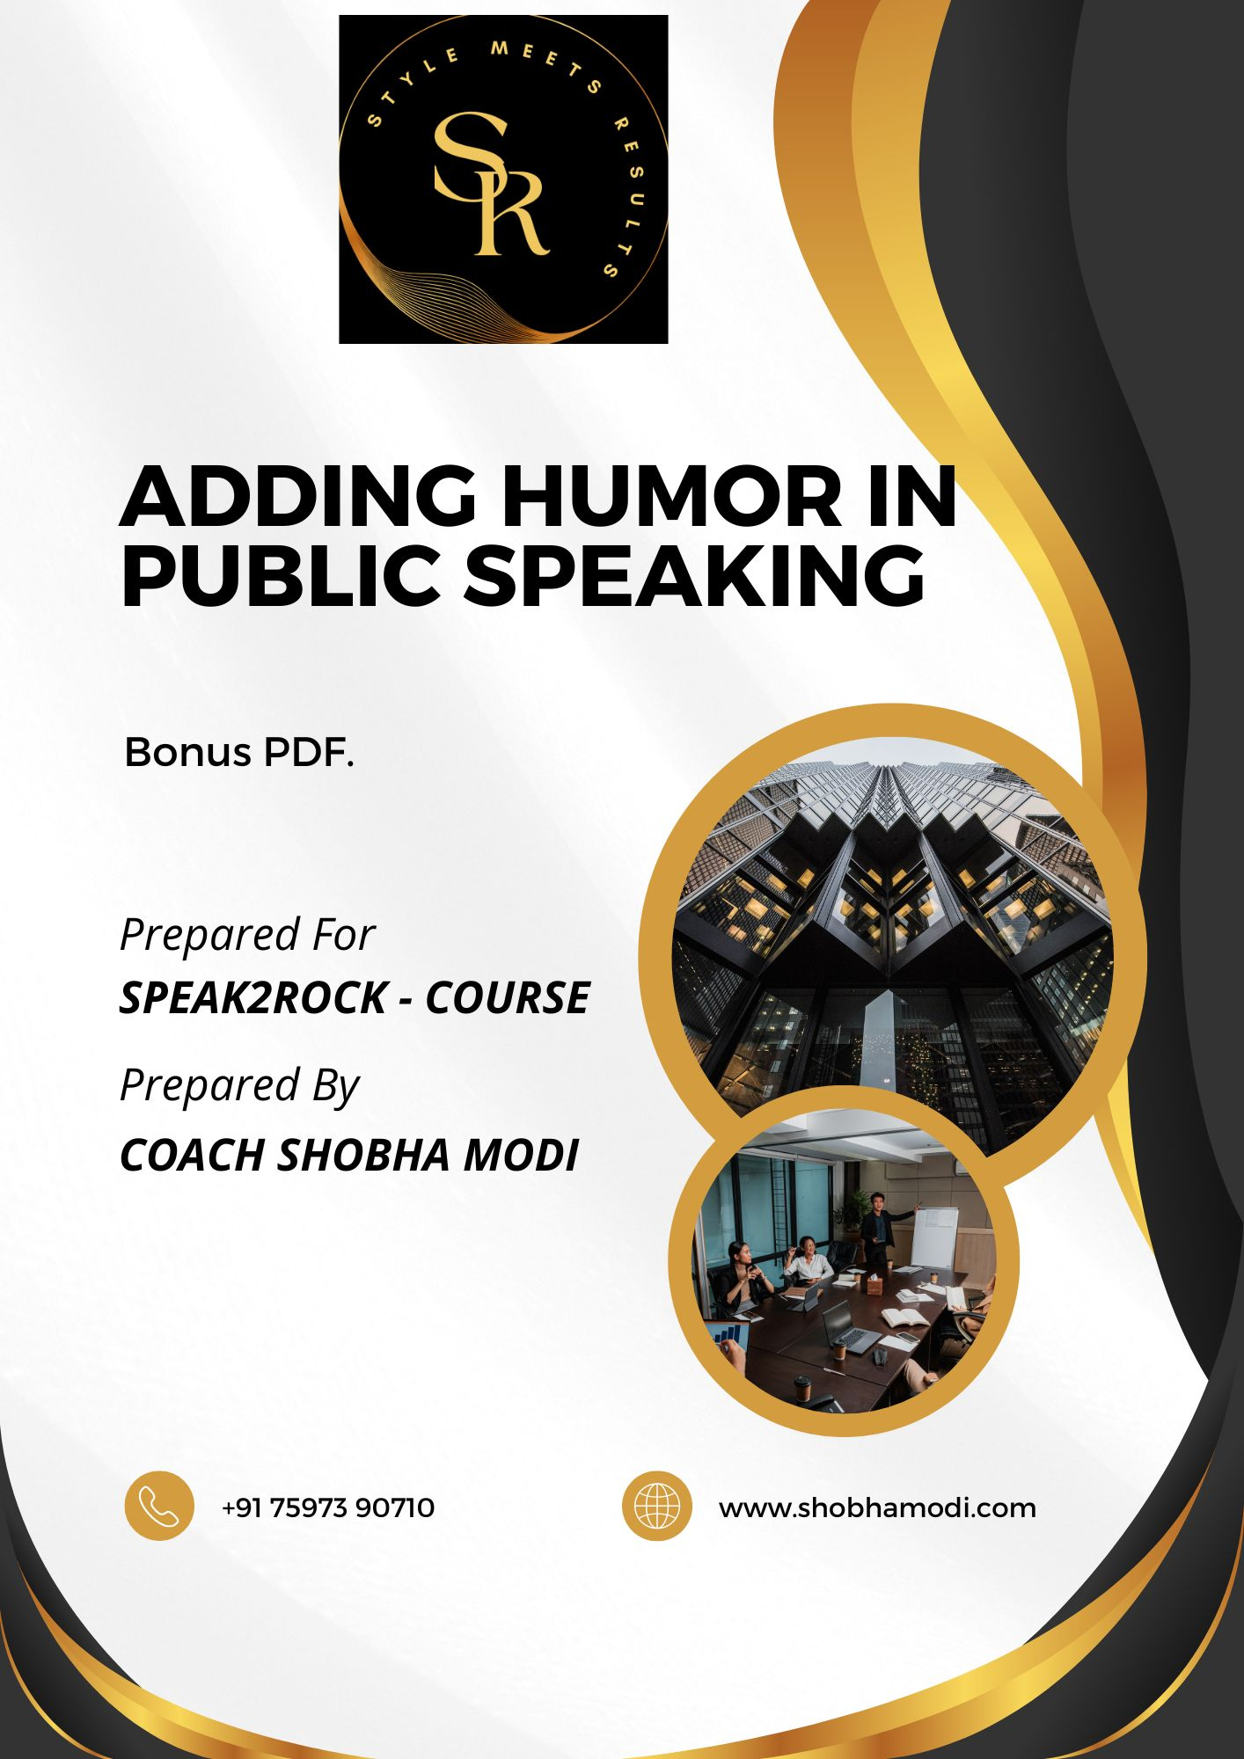
**Adding Humor in Public Speaking**

Introduction
Incorporating humor in public speaking enhances engagement and enjoyment, benefiting both the speaker and the audience. This guide covers the benefits, audience understanding, types of humor, techniques, crafting jokes, cultural sensitivity, overcoming challenges, case studies, practical exercises, and concluding tips for effective humor integration.

- The Importance of Humor in Public Speaking

Benefits of Humor
Humor captures and maintains the audience's attention, making the speaker more approachable. It enhances message memorability, reduces stress, and increases persuasion by creating a positive emotional response and fostering a sense of community and shared experience among the audience.
- Engagement: Captures and maintains audience attention.
- Relatability: Makes the speaker more approachable.
- Memorability: Helps the audience remember key points.
- Stress Reduction: Eases tension for both speaker and audience.
- Persuasion: Enhances the impact of the message.

Psychological Impact
Humor releases endorphins, creating a positive emotional response. It fosters a sense of community and shared experience, breaking down barriers and building rapport between the speaker and the audience, making the communication more effective and enjoyable.
- Releases endorphins, creating a positive response.
- Fosters a sense of community and shared experience.
- Breaks down barriers and builds rapport.

- Understanding Your Audience

Audience Analysis
Consider the audience's demographics (age, gender, cultural background), psychographics (interests, values, attitudes, lifestyles), and the context of the speech (occasion, setting, purpose). Understanding these factors helps tailor the humor to be relevant and appropriate for the specific audience.
- Demographics: Consider age, gender, cultural background.
- Psychographics: Interests, values, attitudes, lifestyles.
- Context: Occasion, setting, purpose of the speech.

Tailoring Humor
Ensure that humor is relevant and appropriate to the audience's background and preferences. Avoid humor that might be offensive or misunderstood, as it can alienate the audience and detract from the speech's effectiveness.
- Ensure relevance and appropriateness.
- Avoid potentially offensive or misunderstood humor.

- Types of Humor

Self-Deprecating Humor
Making fun of oneself can be endearing and relatable, as it shows humility and self-awareness. Sharing a funny personal anecdote can make the audience feel more connected to the speaker, creating a relaxed and friendly atmosphere.
- Endearing and relatable through making fun of oneself.
- Example: Sharing a funny personal anecdote.

Observational Humor
Observational humor comments on everyday situations and common experiences, making it widely relatable. For example, noting the quirks of modern technology can resonate with the audience, creating a shared sense of amusement about familiar scenarios.
- Comments on everyday situations and common experiences.
- Example: Noting quirks of modern technology

Anecdotal Humor
Telling humorous stories with a point engages the audience and illustrates the message effectively. For example, a funny incident that taught a lesson can be both entertaining and informative, helping to convey the speaker's message memorably.
- Humorous stories with a point.
- Example: A funny incident that taught a lesson.

Exaggeration
Exaggeration amplifies the truth for comedic effect, making ordinary statements humorous. For example, saying, "I’ve told you a million times not to exaggerate!" highlights the exaggeration itself, creating humor through hyperbole and making the audience laugh.
- Amplifies the truth for comedic effect.
- Example: "I’ve told you a million times not to exaggerate!"

Satire and Irony
Satire and irony use sarcasm or irony to highlight absurdities, often to make a critical point humorously. Mimicking a well-known cliché to make a point can be effective, as it highlights the absurdity of the cliché and engages the audience through humor.

- Techniques for Integrating Humor

Timing and Delivery
Effective timing and delivery are crucial for humor. Allowing time for laughter (pause), avoiding rushing punchlines (pace), and using facial expressions and body language enhance the comedic effect, making the humor more impactful and enjoyable for the audience.
- Pause: Allow time for laughter.
- Pace: Avoid rushing punchlines.
- Expression: Use facial expressions and body language.

Building a Narrative
Weave humor into the overall story or message, ensuring it flows naturally. Use callbacks to refer back to previous jokes, creating a cohesive and engaging narrative that keeps the audience entertained and reinforces the speech's main points.

Rehearsal
Practicing jokes refines timing and delivery, ensuring they land well with the audience. Getting feedback from trusted individuals helps fine-tune the humor, making it more effective and ensuring it resonates with the audience.

- Crafting Jokes and Stories

Finding Inspiration
Reflect on humorous personal experiences, relate to current events, and tap into universal themes to find inspiration for jokes. These sources provide relatable and engaging material, making the humor more effective and enjoyable for the audience.
- Personal Experiences: Reflect on humorous moments.
- Current Events: Relate to topical issues.
- Universal Themes: Tap into common human experiences.

Structure of a Joke
A joke typically has a setup (introducing the premise), a punchline (delivering the twist or humorous point), and an optional tagline (additional punchline for extra laughs). This structure ensures the humor is clear, concise, and impactful.
- Setup: Introduce the premise.
- Punchline: Deliver the twist or humorous point.
- Tagline: Optional additional punchline for extra laughs.

Testing Material
Try out jokes in smaller settings to gauge reactions and adjust based on audience feedback. This process helps refine the humor, making it more effective and ensuring it resonates well with the intended audience during the actual speech.

- Cultural Sensitivity and Ethics

Avoiding Offensive Humor
Steer clear of jokes that target specific groups or individuals, and be mindful of cultural differences and sensitivities. Offensive humor can alienate the audience and undermine the speech's effectiveness, so it's crucial to be respectful and considerate.

Ethical Considerations
Respect privacy and confidentiality when using humor, and avoid plagiarizing jokes. Ethical humor maintains integrity and credibility, ensuring that the humor is respectful, original, and enhances the speech rather than detracting from it.

- Overcoming Common Challenges

Stage Fright
Use humor to ease nerves and connect with the audience. Practice deep breathing and visualization techniques to calm anxiety, allowing for a more confident and relaxed delivery that enhances the overall impact of the speech.

Bombed Jokes
If a joke fails, acknowledge it humorously and transition smoothly to the next point. Handling bombed jokes with grace and humor shows confidence and keeps the audience engaged, maintaining the speech's momentum and positive atmosphere.

Balancing Humor and Content
Ensure that humor supports the main message rather than overshadowing it. Integrate humor naturally into the speech flow, making it a complementary element that enhances the overall effectiveness and engagement of the presentation.

- Case Studies and Examples

Famous Speakers
Analyze how well-known public speakers use humor to enhance their presentations. Examples like Steve Jobs, Ellen DeGeneres, and Barack Obama demonstrate effective humor integration, providing valuable insights and inspiration for incorporating humor.

Practical Examples
Dissect successful speeches to understand how humor is integrated effectively. Breaking down the elements that make the humor successful provides practical insights and techniques that can be applied to improve one's own public speaking.

- Practical Exercises

Writing Exercises
Develop a list of personal anecdotes and create jokes based on current events. Writing exercises help generate and refine humorous material, making it more relevant and engaging for the audience during the actual speech.

Delivery Practice
Record and review speeches to assess and improve delivery. Practicing in front of a mirror or small audience helps refine timing, expression, and overall delivery, ensuring the humor is effective and well-received by the audience.

Improvisation
Engage in improv activities to enhance spontaneity and quick thinking. Participating in comedy workshops or open mic nights provides valuable practice and feedback, improving the ability to integrate humor naturally and effectively.

- Conclusion

Recap
Summarize the key points on adding humor to public speaking, emphasizing the benefits, techniques, and importance of practice. Reinforce the idea that humor enhances engagement, relatability, and impact, making speeches more memorable and enjoyable.

Final Tips
Stay authentic and true to your style, ensuring that the humor reflects your personality and enhances your message. Continuously learn and refine your humorous approach, adapting to different audiences and contexts for maximum effectiveness.

